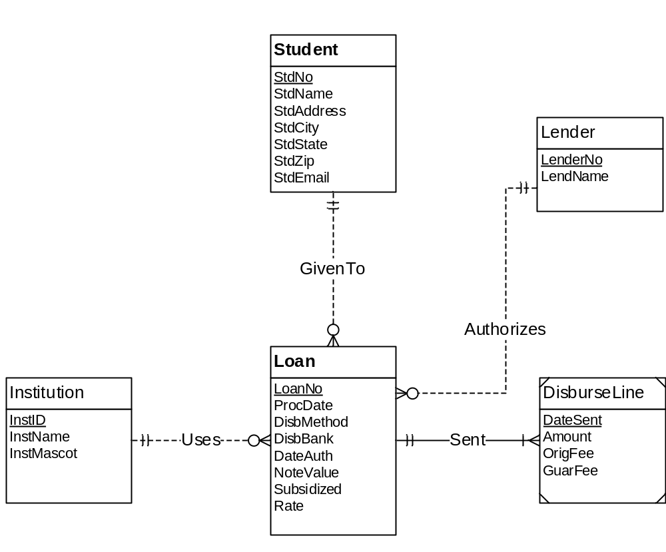
Figure 1: ERD for Problems 1 to 4
Only the Loan and DisburseLine tables have changes from Problem 1 since the 2 are only the child table.

- Loan ( PRIMARY KEY (LoanNo),StdNo,LenderNo,InstID,ProcDate,DisbMethod,DisbBank,DateAuth,
NoteValue,Subsidized,Rate)
FOREIGN KEY (StdNo) REFERENCES Student
FOREIGN KEY (LenderNo) REFERENCES Lender
FOREIGN KEY (InstID) REFERENCES Institution
StdNo NOT NULL
LenderNo NOT NULL
InstID NOT NULL

- The Loan Table added 3 more columns (StdNo,LenderNo,InstID) that are also considered as foreign keys referencing to their respective tables. NOT NULL constraints are indicated for the 3 FKs since the minimum cardinality in the ERD is 1

- DisburseLine ( PRIMARY KEY(DateSent),LoanNo,Amount,OrigFee,GuarFee)
FOREIGN KEY (LoanNo) REFERENCES Loan
LoanNo NOT NULL

- The DisburseLine Table added 1 more column (LoanNo) that is also considered as foreign key referencing to the Loan Table. NOT NULL constraint is indicated for the LoanNo columns since its minimum cardinality in the ERD is 1.

